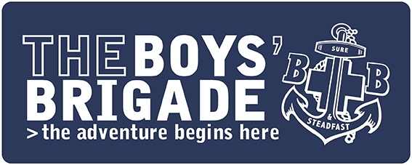

PRESS RELEASE
IMMEDIATE

Youth organisation supports mental wellbeing of young people in [INSERT AREA]
Children and young people at The Boys’ Brigade in [INSERT AREA] will benefit from a range of new programme of activities aimed at exploring and supporting their health and wellbeing.
The Boys’ Brigade, a Christian youth organisation which empowers children and young people aged 4 to 18 years old to learn, grow and discover, has created new programme resources in partnership with YoungMinds, the leading youth mental health charity.
The new resources have been created to help children and young people across different age groups better understand mental health, build resilience, feel equipped to talk openly about their feelings and experiences, and know where to turn for help.
It’s known that children and young people are struggling with mental health more than ever before. With this in mind, there has never been a more important time for youth organisations across the country to support children and young people with their health and wellbeing.
This new programme is part of an ongoing series of resources which the BB has produced focusing on health and wellbeing.

The work of The Boys’ Brigade promotes several ‘protective factors’ outlined by the World
Health Organization (WHO) that are important for mental health and wellbeing including
social and emotional skills, and positive interpersonal interactions.
[INSERT NAME OF SPOKESPERSON] comments: “Here at The Boys’ Brigade, we’re passionate about offering children and young people from all backgrounds a safe space, while also supporting them with life challenges. We understand that talking about mental wellbeing can be a very sensitive subject.
“We hope that through the work we do on a [INSERT DAY OF WEEK] evening, especially the activities around health and wellbeing, we can really help the children and young people that come here. Our aim is to inspire them to live life to the fullest sense, including providing opportunities to explore the Christian faith.”
The Boys’ Brigade in [INSERT TOWN/AREA] takes place on a [INSERT DAY OF WEEK] evening at [INSERT LOCATION] from [INSERT TIMES] and costs just [INSERT COST] to attend as a member. To find your local group, visit The Boys’ Brigade website – you can then either register interest, or just turn up on the day: https://boys-brigade.org.uk
ENDS
For press information please contact:
For more information about The Boys’ Brigade please contact comms@boys-brigade.org.uk or 0300 303 4454

About The Boys’ Brigade
The Boys’ Brigade is a youth organisation which empowers children and young people aged 4 to 18 years old to learn, grow and discover. Rooted in the Christian faith, the organisation has supported millions of people over the last 140 years to experience “life to the full” (John 10:10).
For more information about The Boys’ Brigade and to find your nearest group please visit www.boys-brigade.org.uk

