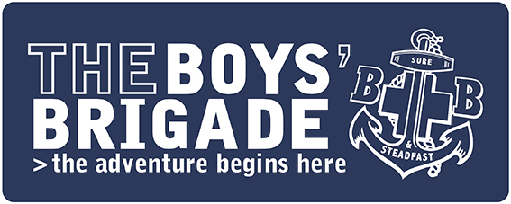

PRESS RELEASE
IMMEDIATE

Youth organisation supports mental wellbeing of young people in [INSERT AREA]
Children and young people at The Boys’ Brigade in [INSERT AREA] will benefit from a range of new programme of activities aimed at exploring and supporting their health and wellbeing.
The Boys’ Brigade, a Christian youth organisation which empowers children and young people aged 4 to 18 years old to learn, grow and discover, has designed a new programme, in partnership with Brain Health Scotland, to help children understand how to keep their brain healthy.
The carefully crafted programme, which will be available to members nationwide, is made up of a range of activities to engage members in tasks which will make them actively think about how to keep their brain happy and healthy.
It’s known that children and young people are struggling with mental health more than ever before. In fact, research from the NHS revealed that more than one in six (18%) children aged between 7 to 16 years old experienced mental health problems in 2022*. This is up from one in nine (12%) in 2017.
With this in mind, there has never been a more important time for youth organisations across the country to support children and young people with their health and wellbeing.
This new programme is part of an ongoing series of resources which the organisation produces focusing on health and wellbeing.

The work of The Boys’ Brigade promotes several ‘protective factors’ outlined by the World
Health Organization (WHO) that are important for mental health and wellbeing including
social and emotional skills, and positive interpersonal interactions.
[INSERT NAME OF SPOKESPERSON] comments: “Here at The Boys’ Brigade, we’re passionate about offering children and young people from all backgrounds a safe space, while also supporting them with life challenges. We understand that talking about mental wellbeing can be a very sensitive subject.
“We hope that through the work we do on a [INSERT DAY OF WEEK] evening, especially the activities around health and wellbeing, we can really help the children and young people that come here. Our aim is to inspire them to live life to the fullest sense, including providing opportunities to explore the Christian faith.”
The Boys’ Brigade in [INSERT TOWN/AREA] takes place on a [INSERT DAY OF WEEK] evening at [INSERT LOCATION] from [INSERT TIMES] and costs just [INSERT COST] to attend as a member. To find your local group, visit The Boys’ Brigade website – you can then either register interest, or just turn up on the day: https://boys-brigade.org.uk
ENDS
For press information please contact:
For more information relating to this press release, please contact [INSERT AN EMAIL ADDRESS OR PHONE NUMBER FOR MEDIA TO GET IN TOUCH REGARDING THE RELEASE IF NEEDED]
For more information about The Boys’ Brigade as an organisation, or any other enquiries, please contact brigade@refreshpr.co.uk / 0161 871 1188
Notes to editors
More information about Brain Health Scotland can be found here: https://www.brainhealth.scot
*https://digital.nhs.uk/data-and-information/publications/statistical/mental-health-of-children-and-young-people-in-england/2022-follow-up-to-the-2017-survey
About The Boys’ Brigade
The Boys’ Brigade is a youth organisation which empowers children and young people aged 4 to 18 years old to learn, grow and discover. Rooted in the Christian faith, the organisation has supported millions of people over the last 140 years to experience “life to the full” (John 10:10).
Today The Boys’ Brigade works with over 20,000 children and young people in over 750 Churches and communities.
For more information about The Boys’ Brigade and to find your nearest group please visit www.boys-brigade.org.uk

