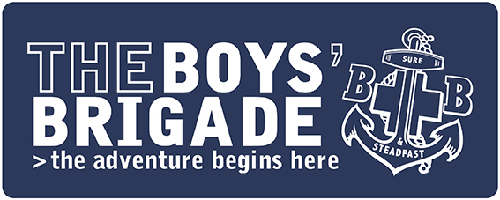

PRESS RELEASE
IMMEDIATE

Young people in [INSERT AREA] raise [£XXX] for [INSERT CHARITY]
A group of children and young people from The Boy’s Brigade in [INSERT AREA] has raised more than [£XXX] for [INSERT CHARITY].
The group aged [INSERT AGES] from [INSERT COMPANY NAME] took part in [INSERT ACTIVITY AND DETAILS].
[INSERT INFORMATION ABOUT THE CHARITY]
[INSERT NAME OF SPOKESPERSON] comments: “Here at The Boys’ Brigade we’re passionate about getting involved with the local community and supporting people from all backgrounds The children and young people at [INSERT COMPANY NAME] have gone above and beyond to be able to raise such an incredible amount for a charity which will benefit many people. We couldn’t be prouder of their efforts!”
[IF POSSIBLE, INSERT COMMENT FROM THE CHARITY]:
The Boys’ Brigade is a Christian youth organisation which empowers children and young people aged 4 to 18 years old to learn, grow and discover in a nurturing environment, rooted in faith. Plus, thanks to the organisation’s varied programme of activities which are available to all groups across the country, individuals have the opportunity to develop skills, build confidence and make new friends.
The Boys’ Brigade in [INSERT TOWN/AREA] takes place at [INSERT LOCATION] from [INSERT TIMES] and costs just [INSERT COST] to attend as a member. To find out more about The Boys’ Brigade visit the organisation’s website: https://boys-brigade.org.uk where you can register your interest in a local group.
ENDS
For press information please contact:
For more information relating to this press release, please contact [INSERT AN EMAIL ADDRESS OR PHONE NUMBER FOR MEDIA TO GET IN TOUCH REGARDING THE RELEASE IF NEEDED]
For more information about The Boys’ Brigade as an organisation, or any other enquiries, please contact brigade@refreshpr.co.uk / 0161 871 1188
About The Boys’ Brigade
The Boys’ Brigade is a youth organisation which empowers children and young people aged 4 to 18 years old to learn, grow and discover. Rooted in the Christian faith, the organisation has supported millions of people over the last 140 years to experience “life to the full” (John 10:10).
Today The Boys’ Brigade works with over 20,000 children and young people in over 750 Churches and communities.
For more information about The Boys’ Brigade and to find your nearest group please visit www.boys-brigade.org.uk

