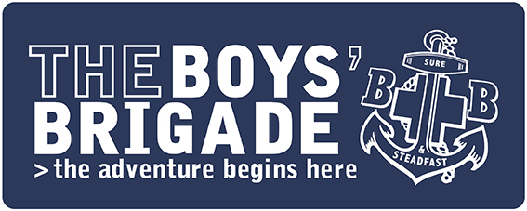

PRESS RELEASE
IMMEDIATE

Young people in [INSERT AREA] bring home the gold
A group of children and young people from The Boys’ Brigade in [INSERT AREA] have been recognised nationally for [INSERT SPORT/ACTIVITY]
The group aged between [INSERT AGES] took part in the organisation’s national competition last weekend and were crowned the winners of [INSERT SPORT/ACTIVITY].
The national event, which saw children and young people coming together from BB groups across the UK is just one of the organisation’s regular national events. Throughout each year, children and young people from all faiths and none are encouraged to get involved with competitions at a regional and national level, as well as annual camps and trips with other groups in their area.
Not only do the events encourage young people to get involved with activities and grow their skillset, but they also allow them to meet other young people from across the country.
[INSERT NAME OF SPOKESPERSON] comments: “Having our members recognised at a national level for [INSERT SKILL/SPORT] is a massive achievement. The children and young people here at [INSERT NAME OF COMPANY] love getting involved with wider initiatives at The Boys’ Brigade and we’re always proud of the amazing efforts they put in to the national competitions!
“However, here at The Boys’ Brigade, we offer children and young people from all backgrounds a safe space where they don’t need to be good at something to be accepted and feel valued.”
The Boys’ Brigade is a Christian youth organisation which empowers children and young people aged 4 to 18 years old to learn, grow and discover. From camping, kayaking and five a side, to first aid, volunteering and crafts, children and young people who attend the group are given the opportunity to learn a whole host of skills.
Plus, thanks to the organisation’s varied programme of activities which are available to all groups across the country, individuals have the opportunity to develop skills, build confidence and make new friends.
The Boys’ Brigade in [INSERT TOWN/AREA] takes place at [INSERT LOCATION] from [INSERT TIMES] and costs just [INSERT COST] to attend as a member. To find your local group, visit The Boys’ Brigade website – you can then either register interest, or just turn up on the day: https://boys-brigade.org.uk
ENDS
For press information please contact:
For more information relating to this press release, please contact [INSERT AN EMAIL ADDRESS OR PHONE NUMBER FOR MEDIA TO GET IN TOUCH REGARDING THE RELEASE IF NEEDED]
For more information about The Boys’ Brigade as an organisation, or any other enquiries, please contact brigade@refreshpr.co.uk / 0161 871 1188
About The Boys’ Brigade
The Boys’ Brigade is a youth organisation which empowers children and young people aged 4 to 18 years old to learn, grow and discover. Rooted in the Christian faith, the organisation has supported millions of people over the last 140 years to experience “life to the full” (John 10:10).
Today The Boys’ Brigade works with over 20,000 children and young people in over 750 Churches and communities.
For more information about The Boys’ Brigade and to find your nearest group please visit www.boys-brigade.org.uk

