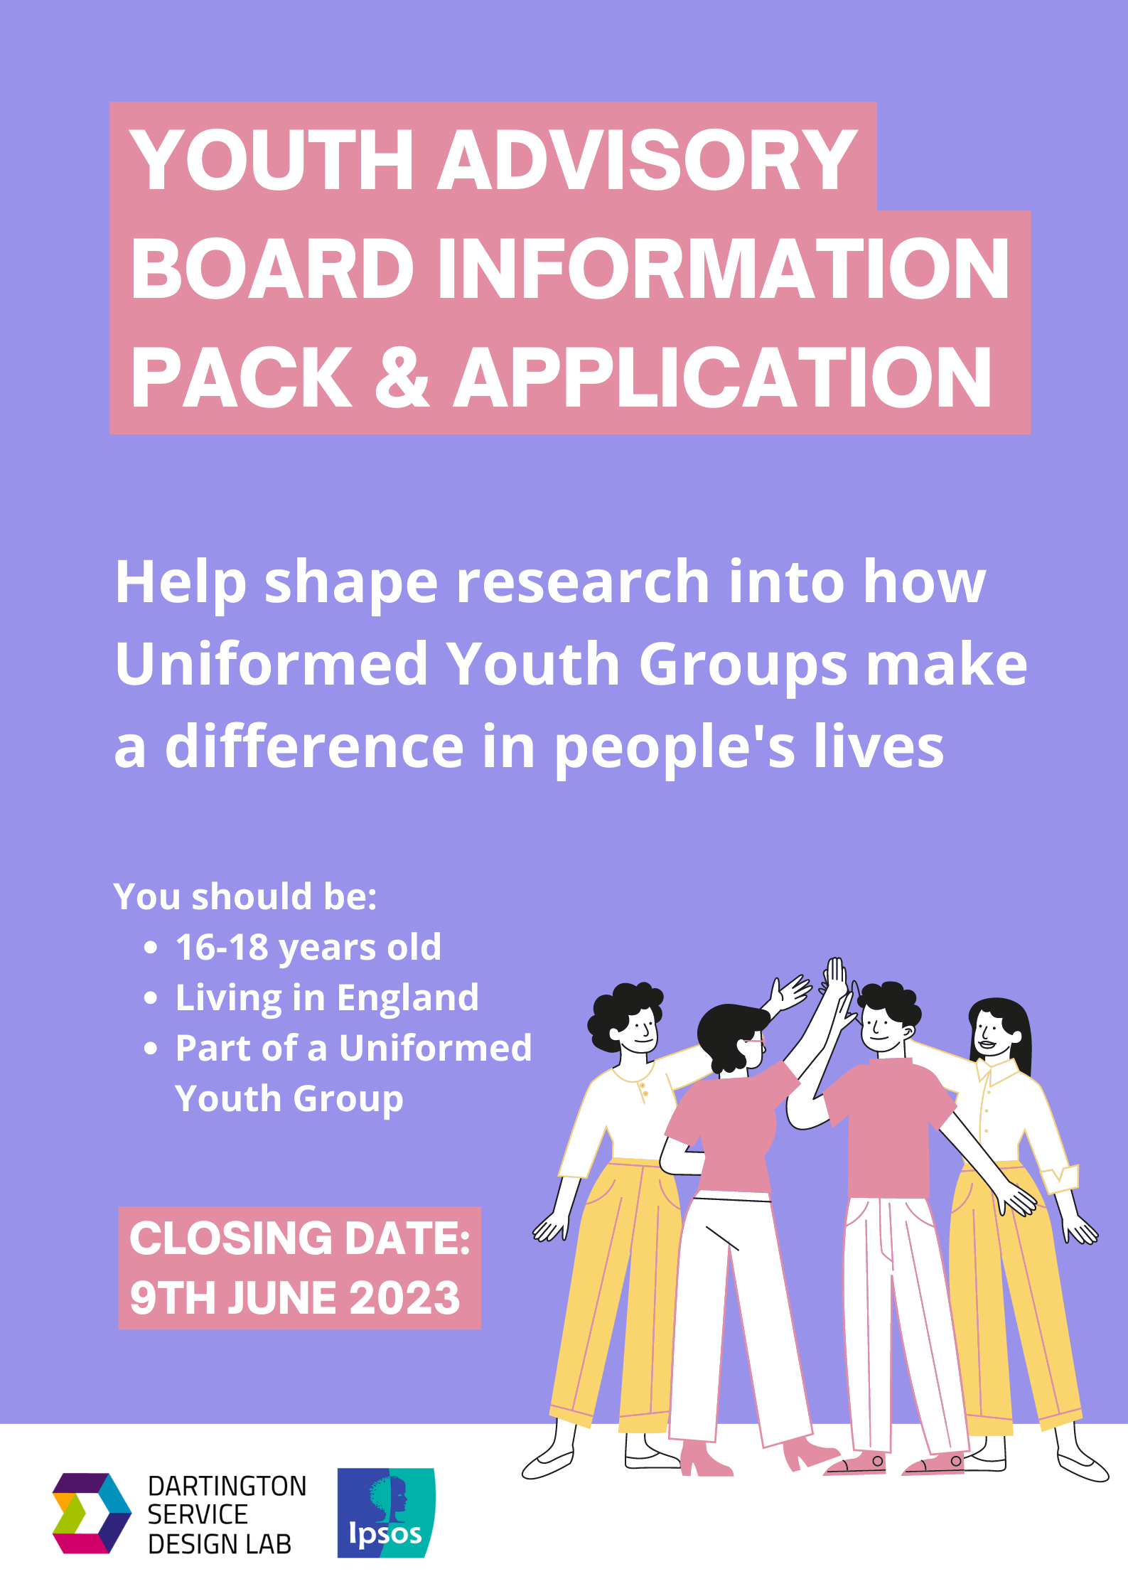

INFORMATION PACK

FOR YOUTH ADVISORY BOARD RECRUITMENT

- What is the Advisory Board?
The Youth Advisory Board is a group of young people who provide advice and guidance to the research team (Dartington Service Design Lab and Ipsos) looking at how Uniformed Youth Groups make a difference in people’s lives. The purpose of this group is to ensure that young people help shape the research and findings that are presented to the Department of Culture, Media and Sports which is the government department that funds Uniformed Youth Groups.
The Advisory Board members will:
- Work alongside the research team to provide advice and ideas from a youth perspective;
- Influence decisions about how the research is done, what it means and what should be recommended to the Government;
- Have opportunities to learn about social research, data collection and interpretation.

- What is the uniformed youth evaluation?
The Uniformed Youth Evaluation is a large piece of research funded by the Government which is focused on understanding the benefits of uniformed youth groups for young people in England. This will involve surveying young people and talking to young people from different uniformed groups to understand what their experience has been of taking part in the group.

- Who can join?
The research team are looking for 18 young people between the ages of 16 to 18 years old. There will be 2 young people from each of the following groups in England:
- Boys’ Brigade
- Fire Cadets
- Girls’ Brigade
- Girlguiding
- Jewish Lads’ and Girls’ Brigade
- St. John Ambulance
- Sea Cadets
- The Scout Association
- Volunteer Police Cadets
We are particularly interested in hearing from young people who are passionate about bringing youth voice into decision making, have an interest in research, who are current members of one of the uniformed youth organisations listed above and have a keen interest in uniformed youth organisations’ work.

- What will you get from being part of the Advisory Board?
- Develop your knowledge, skills and experience: You will be trained in social research skills and work closely with professional researchers. You will be able to use this experience for your CV, and when applying for jobs or courses (we can support you with this).
- Meet new people and have fun: You will have fun with peers in team building activities and get to know each other. You will work with other young people from other uniformed youth groups from across the UK. You will also meet professionals working in research and in government departments who work with uniformed youth groups.
- Opportunities to share opinions and feedback directly to the government officials who fund uniformed youth groups and make a real difference.

- What does being part of the Advisory Group involve?
Being part of the advisory group means committing to attending 7 workshops between June 2023 and February 2025 – 5 of the sessions will happen between June 2023 and November 2023. Most of these workshops will be online but at least two will be in person. Some workshops will be focused on learning about the research, providing your thoughts on the research plans and thinking about the findings/recommendations. Sessions will involve fun, team-building activities and time to get to know each other.

The workshops will cover:
Workshop 1 (in person): Introduction to the Youth Advisory Board (29th June 2023):
- This will be a full day, in person session focused on getting to know each other and the evaluation: it is a combination of fun activities, learnings, and goal settings.
Workshop 2 (online): reviewing the research plan (13th July 2023)
- In this workshop, you will be introduced to the existing research plan and invited to give advice for adjustments where appropriate, so the plan makes sense to you.
Workshop 3 (online): reviewing the survey questionnaire (27th July 2023)
- A survey is used to collect responses to questions from many people to identify similarities and differences across the group.
- In Workshop 3, you will be invited to review the drafted questions, the consent form, and safeguarding documentation alongside professional researchers, to make sure these are clear and fit for purpose to all.
Workshop 4 (online): Reviewing the interview structure and deployment plans (September 2023)
- An interview is used to collect more detailed verbal and non-verbal information from a small number of people.
- This session will focus on what will be asked and how the interviews will be conducted. You will be working with professional researchers to review the language, content, and structure of the interviews, consent giving and safeguarding policies, and how to invite people to take part to make sure these are valid and effective in serving their purposes.
Workshop 5 (online): Interim learnings (November 2023)
- You will help with summarising the first round of interviews in this workshop. Data analysis processes and tools will be explained before we start the discussion.
Workshop 6 (online): Shorter check-in: Learnings (November 2024)
- In Session 6, you will be updated on the evaluation, and consulted about next steps. There will be team building activities in this workshop as well.
Workshop 7 (in person): Final implications and celebration (February 2025)
- In this final workshop, we will focus on the interpretation of overall findings from the first and second round of interviews, thinking about key messages and dissemination approaches. There will be an activity to celebrate the end of the evaluation.

- Will I get paid?
You will be paid for the time that you offer and will be paid £50 per workshop either as cash or a voucher of your choice.
You won’t need to spend your own money to be part of the Youth Advisory Board. When we meet in person, we will pre-book and pay for your travel and offer refreshments and lunch.
- How to apply
Everyone applying will need to complete an application form which will ask for some information about you and why you want to be involved. Once you have submitted your application, we will call you to have an informal conversation to discuss your application.
You can apply in one of the following ways:
- Sending the completed application (included at the end of this pack) to the research team in writing;
- Sending us a short video or audio file (no more than 3 mins) answering the questions in the application form;
- Sending us a piece of artwork that tells us who you are and why you want to join the advisory board;
- Asking for the research team to call you on the phone and talk to us directly about why you want to get involved.
The deadline for applications is 9th June 2023. Completed applications should be sent to Rachel who is in the research team by email rachel.bromley@dartington.org.uk or phone 07467280693. You can also get in touch with Rachel if you have any questions before applying. If you sign up to join the board but want to withdraw at any point you can do so.
- What next?
Once we have your application, we will be in touch to have an informal phone conversation to discuss your application and for you to ask any questions about the advisory group.
Everyone who applies will hear back from us about whether or not they have been selected to be part of the advisory group by 14th June.
For more details please contact:
Rachel Bromley
Email: rachel.bromley@dartington.org.uk
Phone: 07467280693

Application form

We are looking for applications from 16-18 year olds who are currently living anywhere in England.

Section 1: Your details

Name:
Age:
Home Postcode:
Email: | Phone:

Name of the uniformed youth group you belong to (if you do) and how long you have been a member:

Section 2: Different ways to apply

There are different ways to apply for this opportunity! Please select one of the options below:

In writing – please provide your written answers below in section 3
With video – please send us a short video to respond to the questions in section 3
With art – please send us an image file to respond to some / all of the questions in section 3
By phone – if you select this option, one of our team will get in touch with you by phone to guide you through the questions and gather your responses

Any video or image files should be emailed to Rachel at rachel.bromley@dartington.org.uk and should have your name in the subject line.

Section 3: Written answers

If you would like to apply in writing, please write your answers below.

- Tell us a bit about yourself! Use up to 50 words to sum up your personality, interests or passions.

- What are your motivations for joining the Uniformed Youth Advisory Board

Section 4: Diversity monitoring information

The research team want to make sure that the advisory board represents a wide range of young people.

We ask you to complete this form so that we can ensure there is diverse range of group members. The information you give will remain strictly confidential. We will store it securely on a database that only the research team can access. We won’t publish it or use it in any way that identifies you. You do not have to answer the questions on this form if you don’t want to. If you do not wish to answer a question, simply answer ‘Prefer not to say’.

- Your gender (please put an X in the appropriate box)

 | Male |  | Female |  | Non-binary
 | My gender is not listed |  | Prefer not to say

- Your sexual orientation (please put an X in the appropriate box)

 | Bisexual |  | Gay man |  | Gay woman/lesbian
 | Heterosexual |  | Other |  | Prefer not to say

If you prefer to use your own term, please specify here:

- Your ethnic origin (please put an X in the appropriate box)

Ethnic origin is not about your passport or where you were born. It is about your identity and how you feel. Please put an X in the appropriate box(s)

Asian/Asian British

 | Bangladeshi |  | Chinese |  | Indian |  | Pakistani

Any other Asian background, please write in:

Black/African/Caribbean/Black British

 | African |  | Caribbean

Any other Black/African/Caribbean background, please write in:

Mixed/multiple ethnic background

 | White and Black Caribbean |  |  |  | White and Black African
 | White and Asian

Any other mixed background, please write in:

White
 | British |  | English |  | Welsh |  | Scottish
 | Northern Irish |  | Gypsy or Irish Traveller |  |  |  | Other

Any other white background, please write in:

Another ethnic group

 | Arab |  | Prefer not to say

Any other ethnic group, please write in:

- Do you consider that you have a disability?

 | Yes |  | No |  | Prefer not to say

The information in this form is for monitoring purposes only. If you believe you need support during the recruitment process or a ‘reasonable adjustment’ to be a Youth Advisory Board member, then please reach out to Rachel by email at rachel.bromley@dartington.org.uk

Section 5: What are the next steps?

Please email your application form (and any supporting files) to Rachel at
rachel.bromley@dartington.org.uk

Section 6: How will you protect my privacy?

Your privacy is really important to us. By filling in this application form, you are consenting to the Dartington Service Design Lab and Ipsos research team using your personal information to keep in touch with you over the course of this project. If your application is not successful, or you decide to withdraw your application, we will delete your personal data from our files. We will not share your data with people outside of the project team.

If you want to withdraw your consent at any time you can do this by contacting Rachel by email at rachel.bromley@dartington.org.uk

To read our privacy statement please go to: Research Privacy Policy

We look forward to receiving your application!

