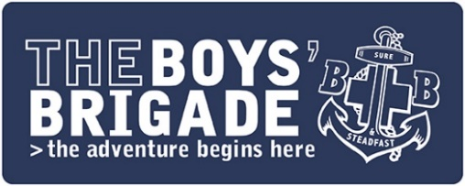
Risk Assessment
Trip to the Park

Leaders are encouraged to undertake a simple risk assessment for BB activities and before embarking on a trip or visit or undertaking a camp or holiday. This form should be used for this purpose. Risk assessments need not be complex but should be comprehensive. Regular activities and frequent visits to local venues such as a swimming pool may not need a risk assessment every time. However, it is essential not to become complacent. An assessment of the risks of such visits should be made at regular intervals.

When completing the risk assessment, consider: what are the hazards; who might be affected by them; what safety measures need to be in place to reduce risks to an acceptable level; who will take responsibility for particular actions; what steps will be taken in an emergency? Once ALL control measures are in place for a specific hazard/risk please put a tick in the box to confirm this.

Company/Battalion/District: | 1st Anywhere | Age Group/Section: | Anchors
Venue / Meeting Space: | Public Park, Main Street, Anywhere | No of children/young people: | 20
Date of activity: | DD/MM/YYYY | No of leaders: | 6

 | Hazard / Risk Identified  What’s the hazard and the risk of harm? | Control Measures  What measures will you put in place to reduce the hazard/risk identified? | Control Measures  in Place | Leader Responsible
1. | Supervision  - Walking from church hall to public park  - Cross over Main Road  - Children wandering off | - Have sufficient leaders available  - Split group into smaller units and allocated two leaders to each  - Give clear instructions to children and leaders before leaving the meeting space.  - All children/young people and leaders to wear BB uniform for ease of identification  - Regularly check numbers |  | R McLeod  J Phillips  S Evans
2. | Venue/Location  - Uneven ground  - Rubbish & dog mess  - Water hazard | - Pre-check area  - Check the area for evenness of ground  - Check for any rubbish or dog mess and clear away  - Locate activities away from water hazards  - Strategically place leaders to steer children away from hazards |  | R McLeod
3. | Equipment  - Safety of games equipment  - Safety of play equipment within the park | - Check games equipment before leaving the meeting space  - Check park play equipment is safe to use and report any defects.  - Ensure appropriate leader supervision throughout |  | S Evans  H Stewart
4. | Other Members of the Public  - Other users of the park  - Stranger danger | - Set up area for use respecting other users  - Remind children about ‘Stranger Danger’  - Ensure appropriate leader supervision at all times – allocate small group to each leader |  | R McLeod
5. | Emergency or First Aid Provision. | - First Aider to provide first aid for minor injuries  - First Aid Kit available and access to medical details for all children through OBM or Annual Information Forms  - Mobile phone for dealing with emergencies which may require outside assistance or contact between leaders |  | G Spence
Review: This risk assessment should be reviewed on completion of the activity and updated for future use and reviewed regularly where a frequent activity.

Approved by  Leader/Officer  in Charge of age group | Name: R McLeod  Role: OIC Anchors  Date: DD/MM/YYYY  Signed: R McLeod | Approved by  Company Captain | Name: J Williamson  Role: Captain  Date: DD/MM/YYYY  Signed: J Williamson
Please note: Approval for activities being run by Battalion/Districts should be by a minimum of two Officer Bearers (Secretary, President, Treasurer, Vice-President).

If an accident occurs during the activity, please remember to log the details in your accident book. Where professional medical attention is required you MUST complete an Accident Report Form and submit to BB Headquarters.

