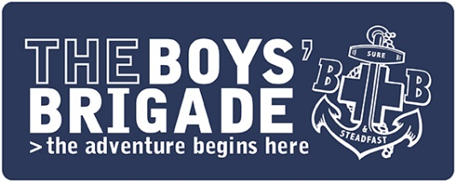
TEMPLATE LETTER TO MEMBERS & PARENTS/CARERS – SPRING ACTIVITY PACK
[Insert Company Name, Logo and Contact Details]

[Insert DATE]

[Insert Member’s & Parent/Carer Name]

Spring 2021 Activity Pack

We hope you and your family are safe and well.

We are missing you very much at Boys’ Brigade and we can’t wait to be able to welcome you back, when it is safe to do so.

In the meantime, please find enclosed an activity pack from us, to help keep you occupied over the coming weeks. This pack includes a double sided A3 activity sheet with different challenges for you to try, as well as [Insert any other activities, treats etc if you have decided to include them]. We hope you will enjoy completing the activities and they will help to keep you busy whilst we are unable to meet.

We’d love to know how you get on with the activities so, if you are comfortable to do so, please send us some photos. It would be great to be able to see our members taking part in the activities and challenges. You can send photos to us by [Insert the best method for you to receive photos (i.e email, social media, WhatsApp etc)]

On the activity sheet, you will notice that there are some #BBatHOME challenges that you could try out. We hope that you will give one or two of these a go. If you enjoy completing them and would like to try some more, then you will find 100’s more #BBatHOME activities at https://boys-brigade.org.uk/programme/bbathome-activities/. These challenges are split into different activity areas, meaning you can choose to take on activities which get you active, adventurous, creative, into the Bible, involved or learning. If you do complete some of these activities, then please let us know how you get on.

This last year has seen us miss out on so many activities and adventures, we hope it won’t be too long now until we are back at Boys’ Brigade again doing all the things we love. [If you are able, provide an update from your Company about your hopes/plans for a return (i.e if you hope to return in the summer for activities) to give your members something to look forward to and get excited about]

Until we are able to meet again, we hope you enjoy completing this activity pack and we look forward to seeing you again soon.

Best wishes,

[Insert name & Company]

