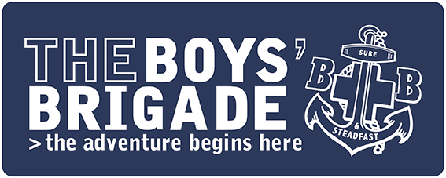
Mini Grants for Growth
Supported by Guild Partnership
APPLICATION FORM

Grants of up to £1,000 to support the growth of the Brigade in Scotland and improve the quality of experience offered to children and young people.

Round 4 – closing date 4th January 2021

Please read the guidelines carefully. You must complete all sections of the form.

Section 1 – Company Details

Company Name
Contact Name (this is the person we will contact to discuss/clarify your application, if required)
Position
Correspondence Address | Postcode
Email Address
Daytime Telephone Number
Evening telephone Number
Mobile Number
Company’s website
or Facebook page address
Company Meeting Place

For office use only
Reference Number | Grant Requested | Grant  Awarded | Monitoring Report due | Report  Received
Section 2 – Proposed activities

In this section we want you to tell us what you want the funding for and why?

How many young people will benefit from this funding?

Age Group | Male | Female | Total
Anchors (P1 – P3)
Juniors (P4 – P6)
Company (P7 – S3)
Seniors (S4 – S6)
Young Leaders (Up to age 26)
Totals

Please describe the proposed activity for which you are applying for funding.
Please provide as much detail about the activities as possible.

Expected start date |  | Expected completion date

What impact will this funding have…on?

Young people
Volunteers
The Community
The need for the project should be identified through completion of the Company Healthcheck. What aspect of check identified the need for this project?

***A copy of the completed Healthcheck Action Plan should be included***
Did you consult young people, and if so, what did they say?

How will you record what you have achieved, as a result of the funding?

Section 3 – Finance and Budget

Item of Expenditure (A) | Estimated Cost £
Totals (A) | £
LESS Income from other sources (B) | £
Mini Grant requested (C) | £
Note: A – B = C
If you have attracted income from other sources, please tell us about this below
Income from other sources (B) | Is funding confirmed? | Amount £
 | Yes/No
 | Yes/No
 | Yes/No
 |  | £

Section 4 – Signed Statements
To the best of my knowledge, the information given on this form gives a true and accurate account of the Company’s work and needs. I confirm that this application will enable our BB Company to grow local provision for young people, through provision of the activities listed on page 2.

Applicant’s Name (in Block Capitals)
Signature
Date
Captain/Chaplain’s (delete as appropriate) Name
Signature
Date
Contact Telephone Number
Please return applications by 4th January 2021
Email (preferable)
scottishhq@boys-brigade.org.uk
Post
The Boys’ Brigade, Carronvale House
Carronvale Road, Larbert FK5 3LH

Section 5 – Checklist

Answered all the questions on the application form
Application is signed
Application is countersigned
Copy of most recent annual accounts enclosed
Copy of Company Healthcheck action plan enclosed
The Boys’ Brigade, Scottish Headquarters, Carronvale House, Carronvale Road, Larbert FK5 3LH
T: 01324 562008 (Option 1) F: 01324 552323 facebook.com/TheBBScotland @TheBBScotland

Scottish Charity Number SC038016

