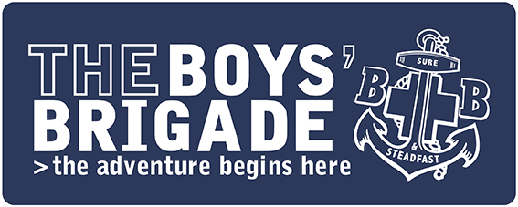

PRESS RELEASE
IMMEDIATE

Stronger, Safer, Together – Local Boys’ Brigade Group Plans to Restart
It has been a challenging year so far for the young people who are members of [Insert Company Name]. Face-to-face BB activities have been suspended since March, meaning that several key events and activities such as [Insert] have been missed.
[Company Name] hasn’t allowed Coronavirus to bring their activities to a complete standstill, however. After face-to-face activities stopped, The Boys’ Brigade launched #BBatHOME, an online programme of activities for children and young people of all ages to take part in at home with their families. Around 300 activities were provided across 18 weeks, and the group’s volunteer leaders are now starting to put into place their framework for returning to face-to-face activities.
[Insert Quote from Captain or Leader about looking forward to restart and details of date/times. Suggested inclusion - “[Company Name] has a thorough roadmap laid out for its return to face-to-face activities, with the main emphasis on safety for everyone”.]
[Insert Quote from Member or Parent/Carer about the restart of BB.]
Boys’ Brigade’s Chief Executive, Jonathan Eales, has said, “We are excited to be supporting our local groups with their return to face-to-face activities. The Boys’ Brigade as we know it may have been suspended since 16 March, but our volunteer leaders have continued to work hard to serve their local communities throughout Lockdown; we couldn’t be more proud of them. The way in which the wider Boys’ Brigade family has adapted in the face of adversity leaves me with little doubt that we will emerge from this stronger than ever”.
If you’re interested in learning more about [Insert Company], you can visit [boys-brigade.org.uk or insert Company’s own URL].
-ENDS-

Notes to Editors
- The Boys’ Brigade (BB) was founded in Glasgow on 4th October 1883 by Sir William Alexander Smith.
- Find out more about BBatHOME: https://boys-brigade.org.uk/bbathome/
- The vision of the BB is that children and young people experience “life to the full.” (John 10:10)
- Over 40,000 children and young people are Boys’ Brigade members in the UK.
- Photos available on request

For more information please contact: [Contact Details]

