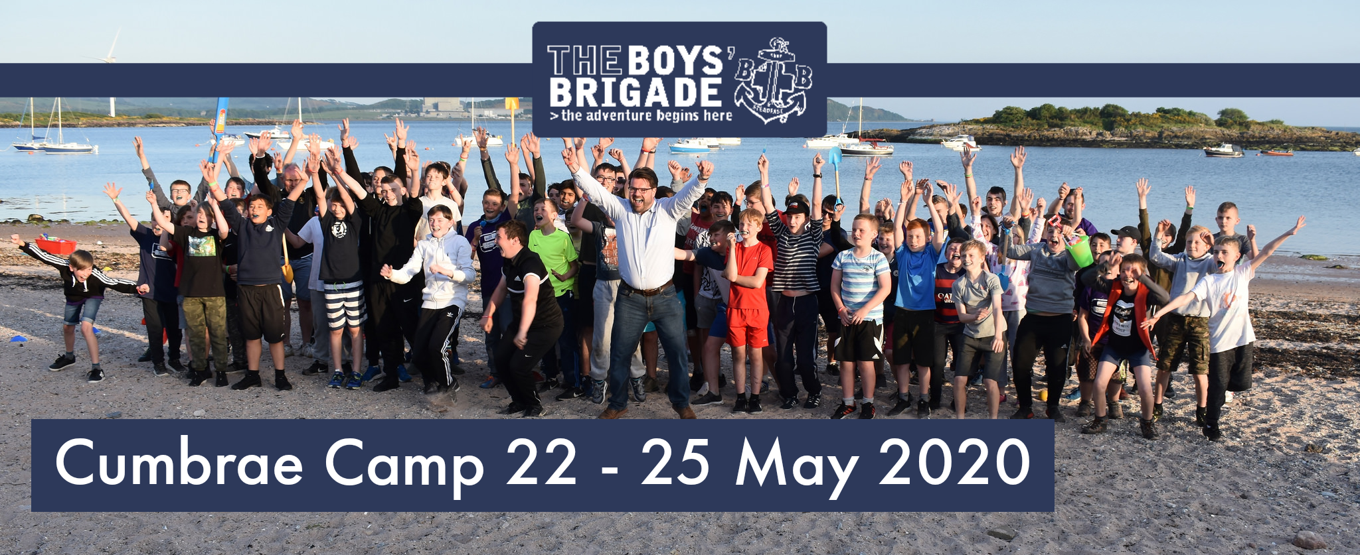

Cumbrae Camp 2020 – Registration Information

Thank you for registering your interest in the national canvas camp to be held on the Isle of Cumbrae in May 2020.

The event will take the form of a national canvas camp with young people attending from right across Scotland, and participants will be involved in a varied and exciting programme, which will include team sports, cycling, water sports, beach games and so much more.

Could you please complete the attached application form and return it with a non-refundable deposit of £20 per person (including staff) by: Friday 10th April 2020.
(Companies should note that applications will be accepted on a first come, first served basis.)

The remaining balance of £60 per person must be paid by Friday the 24th April 2020.

Camp information booklets will be sent out in due course for all attending camp. In the meantime, please don’t hesitate to get in touch with the Scottish HQ team with any questions about the event.
Please send completed application(s) and deposits of £20 per person to:

Cumbrae Camp
Boys’ Brigade Scottish Headquarters
Carronvale House
Carronvale Road
Larbert
FK5 3LH
Or by email to:
Irene.davidson@boys-brigade.org.uk
To make card payments over the phone, please call (during office hours) 01324 562008 (option 1)

The Cumbrae Community and I look forward to seeing you at camp on the 22nd to 25th May 2020!
Kind regards,
Jackie Wilson | Development Officer
Jackie.Wilson@boys-brigade.org.uk

Cumbrae Camp Company Application 22nd – 25th May 2020
Company Name
Main Contact for Company | Name:  Address:  Post Code: | Phone Nos:  Mobile:  Email:
Camper’s Name | Date of Birth | Deposit Paid £20

