1979 2019

40th ANNIVERSARY

SCOTTISH BANDS CONTEST

HUTCHESON’S GRAMMAR SCHOOL, GLASGOW

SATURDAY 23rd MARCH 2019

ENTRY FORM
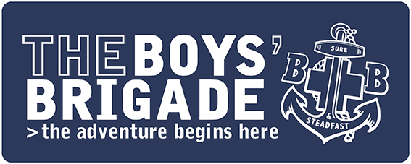

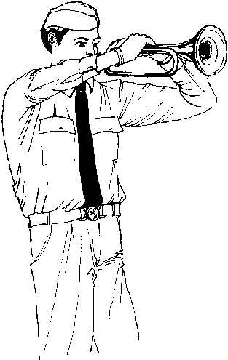
Entries are invited from any Boys’ Brigade, Boys’ Brigade with Girls’ Association or BB/GB bands from across Scotland for the 40th Anniversary Scottish Bands Contest, to be held in Hutcheson’s Grammar School in Glasgow on Saturday 23rd March 2019.

The Contest will be in three sections:
Pipe Band
Marching Band
Concert Band (new for 2019)

competing in three classes:
Development (Pipe/Marching)
Championship (Pipe/Marching)
Performance (Concert)

The Pipe Band and Marching Band formats will be similar to previous years. The Concert Band Section has been introduced to showcase musical talent. Bands will not be competing against each other, are able to play seated and will be graded in a Bronze, Silver or Gold category. Adjudication sheets will provide feedback on performance and development ideas for improvement.

Please refer to individual Contest Information sheets for more detail.

Entry Fee: £15 per Company/Battalion

(Please make cheques payable to ‘The Boys’ Brigade’)

and return to:
The Boys’ Brigade,
Scottish Headquarters
Carronvale House,
Carronvale Road,
Larbert FK5 3LH

Closing date for entries: Monday 25th February 2019
2019 SCOTTISH BANDS CONTEST - ENTRY FORM

Company OR Battalion
Bandmaster/OIC
Contact for whom correspondence should be sent
Name
Address

Postcode
Tel No.
Email Address
Mobile Contact
(for contest day)
Expected strength of band (approx)
Number of staff (approx)

We wish to enter the undernoted band(s) for the 2019 Bands Contest,
and agree to abide by the Contest Rules.

The entry fee of £15 per Company/Battalion is enclosed
(cheques should be made payable to ‘The Boys’ Brigade’)

Bandmaster ________________________________

Section of Competition | Number of Bands
Pipe Development (formerly Novice)
Pipe Championship
Marching Band Development (formerly Novice)
Marching Band Championship
Concert Band
Mallets Player (young person, not an Officer) | YES / NO
Drum Major (young person, not an Officer) | YES / NO

I wish to pay by Visa/Mastercard. Please charge my account with £15.
For Office Use
Fee  Received |  |  | Name on Card |  |  |  |  |  |  |  | Expiry Date |  |  |  |  | Security Code (3 digit no on signature strip)
Receipt  No. |  |  | Signature

