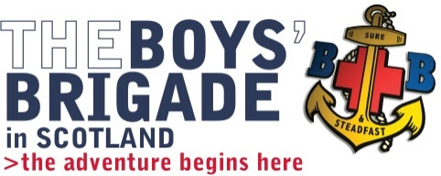
Name: _______________________
Company: ____________________

King George VI 27th JULY – 2nd AUGUST 2018
Youth Leadership Training
APPLICATION FORM
This application should be completed in BLOCK CAPITALS and returned to The Boys’ Brigade, Scottish Headquarters, Carronvale House, Carronvale Road, Larbert FK5 3LH
SECTION A: Personal Details
Name in Full: __________________________________________________________
Christian name to be used on course name badge: ___________________________
Address: ______________________________________________________________
_____________________________________________________________________
_____________________________________________________________________
Postcode: _____________________ Telephone:__________________________
Mobile Number: _______________________________________________________
Email Address: _________________________________________________________
Date of Birth: _______________________ Age: (as at start of course) ____________
Company: ____________________________________________________________
Battalion: _____________________________________________________________
Company Church attachment: ____________________________________________
School attended or employment: __________________________________________
Please note any other similar training that you have undertaken? _______________
_____________________________________________________________________
Do you suffer from any illness or disability that is likely to influence your participation in the course? Please provide details below? ________________________________
_____________________________________________________________________
Do you have any special dietary requirements? Please provide details below?
_____________________________________________________________________
Applicants should provide answers to each question, where applicable

SECTION B: Boys’ Brigade Background
Length of BB service [ ] years

Awards Gained (please circle all that apply)
Compass 1  Discovery 1 | Community 1 2 3 4  Recreation 1 2 3 4  Skills 1 2 3 4 | President’s Badge (date) ____________  Queen’s Badge (date) ______________  (if working for, indicate present position)
Duke of Edinburgh’s Award (date gained – tick [ ] if working towards)
Bronze _______________ [ ] Silver _______________ [ ] Gold _______________ [ ]
What leadership experience have you had within The Boys’ Brigade?

What is your long term role within The Boys’ Brigade?

Tell us why you have chosen KGVI as your route to completing your training?

Section C: Church Background
Are you a church member? Yes [ ] No [ ]
What involvement, if any, do you have with the church, out with The Boys’ Brigade?

Section D: Declaration and Endorsements
I wish to apply for entry to KGVI Youth Leadership Training and declare that I am willing to undertake the full training, as outlined in the information sheet.
Applicants signature: _________________________________ Date: __________________
We consider ____________________________ to be a suitable applicant for officer training and enclose a cheque for to cover the course fee for the New Entrants course.
Captain’s signature: ___________________________________ Date: __________________
Chaplain’s signature: __________________________________ Date: __________________
Captain’s contact details (name, address, email, telephone no):
Name: ____________________________ Telephone: _______________________________
Address: ___________________________________________________________________
Email address: ______________________________________________________________

