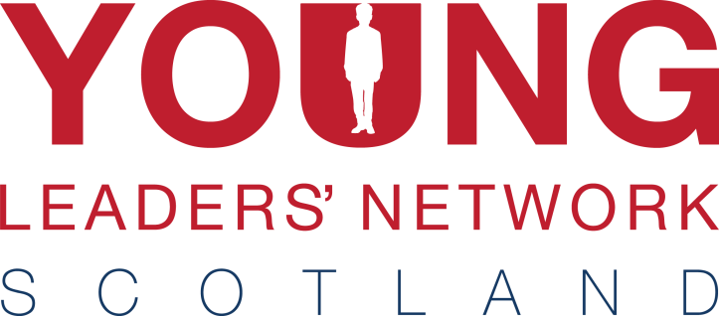

European Trip

This year’s young leaders’ trip is to the Hungarian capital Budapest! The city is undoubtedly one of Europe’s most spectacular and historic capitals. The four-day, three-night excursion departs on June 25th and returns June 28th.

Sitting on the river Danube, it’s a city brimming with history and there is no shortage of things to do – from exploring the amazing buildings such as Buda Castle and boat trips on the river, to wandering through markets and sampling the array of traditional dishes.
Above all, you’ll get the chance to explore an amazing city in the company of other BB young leaders from across the country.

When? 25th – 28th June 2018

Who can come? Young Leaders active in BB companies in Scotland aged 18 - 25

What do I need? A valid passport and passion for seeing new places!

Programme A more detailed itinerary will be shared closer to the time. However, it’s safe to say we will pack in as much as possible. Sightseeing, sampling the local cuisine, excursions and even daft team challenges are all in the mix! There will also be free time for you to do your own exploring.

Cost We have been able to reduce the cost for this three-night, four-day trip to £265. This will cover return flights to Budapest from Edinburgh, public transport, hotel, breakfast, dinner and insurances.

Interested? Please get in touch using the details below to register. (Places are very limited so please get in touch as soon as possible)

A £50 non-refundable deposit is required by Friday 2nd March 2018 at the latest.

If you would like some further information or have any questions regarding the trip, please get in touch with Irene Davidson by email irene.davidson@boys-brigade.org.uk or by calling 01324 562008.

For Office Use
Date recd.
Ref. No.
Bal. paid

Participant’s Details:

Christian Name: ___________________ Surname: _________________ Date of Birth: _______________

Company:_________________________________________________________

Address: _______________________________________________________________________________
_______________________________________________________________________________________
_____________________________________________________________ Postcode: ________________
Tel No: Daytime: _______________ Evening: __________________ Mobile: ______________________

Email address: _______________________________________________________________________________

PLEASE COMPLETE ACCURATELY AND CAREFULLY AS DETAILS USED FOR FLIGHT BOOKINGS
Payment Details: Please √
I enclose a cheque for £50 being a non-returnable deposit for the Budapest trip.
The balance to be paid, no later than 27th May 2018. Payments can be made in instalments. Total cost of trip is £265
Please charge £________ to my Visa/Mastercard – details below
I will make a payment over the phone. (01324 562008 – option 1)
Visa/ Mastercard: _____/_____/_____/_____ Expiry Date: _____/_____ Security Code ______ (3 digit
number from signature strip on reverse of card)

Name and Address (if different from above): ____________________________________________

_______________________________________________________ Postcode: __________________

Signature:____________________________________________ Date:______________________

Please return completed form, together with the required payment to:
The Boys’ Brigade
Carronvale House
Carronvale Road
Larbert
FK5 3LH
Please make cheques payable ‘The Boys’ Brigade’

Alternatively, you can email forms to irene.davidson@boys-brigade.org.uk

