39th SCOTTISH BANDS CONTEST

HUTCHESON’S GRAMMAR SCHOOL, GLASGOW

SATURDAY 10th MARCH 2018

ENTRY FORM

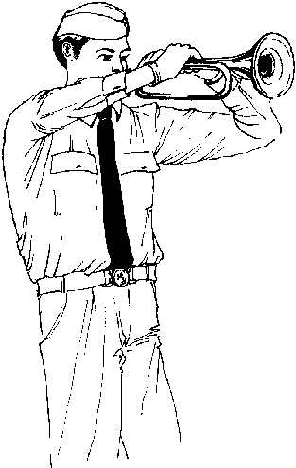
Entries are invited from any Boys’ Brigade or Boys’ Brigade with Girls’ Association bands from across Scotland for the 2018 Scottish Bands Contest to be held in Hutcheson’s Grammar School in Glasgow on Saturday 10th March 2018.

The Contest will be in three categories:
Open (Wind)
Pipe
Mini Pipe
competing in three classes:
Novice
Contest
Championship

Competing bands will be placed in a class by the Bands Committee. The previous year’s competition winners being upgraded by one class and the bottom band in each class may drop down a grade. Due consideration will however be given to the class preferred by the band.

Entry Fee: £14 per Company/Battalion

(Please make cheques payable to ‘The Boys’ Brigade’)

and return to:
The Boys’ Brigade, Scottish Headquarters
Carronvale House, Carronvale Road, Larbert FK5 3LH

Closing date for entries: Friday 16th February 2018

2018 SCOTTISH BANDS CONTEST - ENTRY FORM
Company OR Battalion
Bandmaster/OIC
Contact for whom correspondence should be sent
Name
Address

Postcode
Tel No.
Email Address
Mobile Contact
(for contest day)
Expected strength of band (approx)
Number of staff (approx)

We wish to enter the undernoted band(s) for the 2018 Bands Contest,
and agree to abide by the Contest Rules.

The entry fee of £14 per Company/Battalion is enclosed
(cheques should be made payable to ‘The Boys’ Brigade’)

Bandmaster ________________________________

Section of Competition | Number of Bands
Mini Pipe Novice
Mini Pipe Open
Pipe Novice
Pipe Contest
Pipe Championship
Open (Wind) Novice
Open (Wind) Contest
Open (Wind) Championship
Mallets Player (young person, not an Officer) | YES / NO
Drum Major (young person, not an Officer) | YES / NO

Please turn over and complete, if you wish to pay by credit card.
I wish to pay by Visa/Mastercard. Please charge my account with £14.
My card number is (13 or 16 digits):

For Office Use
Fee  Received |  |  | Name on Card |  |  |  |  |  |  |  | Expiry Date |  |  |  |  | Security Code  3 digit no on signature strip
Receipt  No. |  |  | Signature

