AVON BATTALION,  THE BOYS’ BRIGADE | 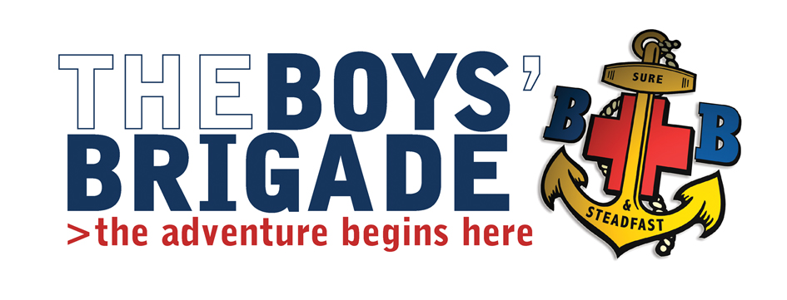

Development Worker (Bristol Area)

Person specification

Avon Battalion covers a large, exciting, multicultural area of the South West.

We wish to appoint a highly motivated and highly skilled Development Worker who is a team player to work alongside a friendly, enthusiastic and forward thinking Battalion.

We are looking for someone who develops work with children for the right reasons: children only get one chance for a great childhood in which to develop. Do you have the skills, passion, resilience and ambition to make their precious time with us the best it can possibly be?

Essential Skills and Knowledge

1. Youth Work
- At least a year’s recent experience of working with young people in an informal setting.
- Be able to demonstrate a knowledge of and commitment to young people’s participation processes.
- Be able to demonstrate a commitment to the values underpinning Youth and Children’s Work

2. Influencing and communication skills
- Demonstrate real enthusiasm and commitment towards raising awareness of the Boys’ Brigade within our community.
- Be a team player with excellent communication and interpersonal skills - able to work positively with colleagues, volunteers, parents and children;
- Positively promote inclusion and have high expectations for all members;
- Be resilient and hardworking and eager to share and develop their practice
- Demonstrate the ability to influence people to buy into an idea or proposal for new projects
- Demonstrate excellent presentation skills to both groups and individuals in formal and informal settings
- Have the ability to deliver training
- Have good verbal and written communication skills

3. Project management
- Have proven experience in creating strategies to meet aims and targets for a project.
- Be able to plan, manage and co-ordinate own workload
- Be able to produce accurate and concise reports.
- Familiarity with Microsoft Office packages is required

4. Promoting equality of opportunity
- Should be able to demonstrate a clear understanding of the main areas of disadvantage affecting young people in the UK
- Should be able to demonstrate strategies to maximise access to all groups of young people.

5. Personal Skills
- A commitment to personal reflection and continual development
- Enthusiasm, flexibility, ambition, resilience, reliability, and a ‘can do’ approach offered with a sense of humour
- Supportive of the aims and values of a Christian organisation in the context of an inclusive multi faith environment.

The BB is a Christian organisation and applicants should be in sympathy with the aims and mission statement. An understanding of faith based youth work and the needs of local churches would be advantageous. The role will involve visiting churches and community groups and access to own transport would be advantageous. There will also be an element of travel to Brigade HQ in Hemel Hempstead to attend training, meetings and networking with other Development Officers.

For further information about The Boys’ Brigade visit our web site www.boys-brigade.org.uk

Two fully supportive references to cover all the candidate’s professional and personal
qualities. The post will also require a satisfactory disclosure check (DBS) at an
enhanced level.

September 2015

