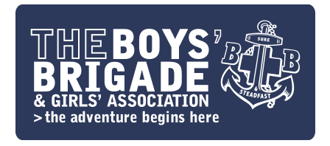
Appointment of a Development Worker – Based within the M25 corridor

General information

The Boys' Brigade
The Boys’ Brigade is a UK wide voluntary sector youth organisation for children and young people with around 680 groups, 6300 volunteer leaders, and around 17000 members in England & Wales. We partner with the main denominations of the Christian church to provide a wide variety of fun and educational activities for children and young people, including camps and holidays. More information can be found at www.boys-brigade.org.uk

We are seeking to appoint another Development Worker to support our development initiatives throughout England & Wales. The development worker will be required to attend church services as part of the role and, on occasion, to lead or play a prominent role in acts of worship. It is therefore an occupational requirement that the post holder should be a practicing Christian who must be able to demonstrate empathy and sensitivity to the ecumenical nature of The Boys’ Brigade. The appointment is for 24 months, the worker will be home based.

The Development Worker will work with local volunteers and other nationally employed staff to support and improve the programmes offered to members, and to assist with the delivery of the Brigade’s Development Plan in the area.

Appointment will be subject to two references and the completion of an enhanced DBS check.

Travel
The Development Worker should be a car owner with a clean driving licence. A mileage allowance, currently 45p per mile, will be paid for business use.

Salary
The salary for this post is £24,227 per annum based on a 35-hour week. There is an annual leave entitlement of 25 days leave plus statutory and bank holidays. A flexi-time system is worked, as there will be a considerable need to work evenings and weekends.

Closing Date
21st June 2016

Interviews will be held at Felden Lodge, Hemel Hempstead on 30th June 2016

If you would like to have an informal discussion about this post before submitting an application please contact Eric Hudson, Director for England on 0773 6475468

Only candidates invited for interview will be contacted

May 2016

Job Description

Main purpose of role:
To support and develop existing companies in England & Wales with a focus within and around the M25 corridor and where possible establish new groups. Travel outside of the M25 corridor will also be required for specific projects.

Responsible to: The Director for England & Wales

Summary of key responsibilities

- To support existing groups (BB companies) and assist them to recruit more leaders and
members.

2. Encourage use of the relevant programme materials for all age groups within the company.

3. To help develop and improve the programmes and experience offered to current members.

- To assist with the delivery of the Brigade’s Development Plan in the area.

- Support companies in delivery of Duke of Edinburgh Award

6. To promote training / opportunities for volunteers.

7. To assist in the delivery of any national projects as directed.

8. To promote and publicise the work of the Brigade in the target area.

9. Other relevant related duties as required.

May 2016

