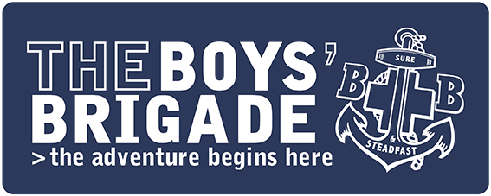

PRESS RELEASE
IMMEDIATE

“We’re open” – Local Boys’ Brigade Group Restarting
The Boys’ Brigade in [ADD - location/Company name] is back with a clear message – “we’re open”.

The group provides opportunities for children and young people to learn, grow and discover in a safe, fun and caring environment. There’s opportunities to develop skills, build confidence, make friends, work towards awards, make a difference in the local community and of course have fun.

The youth organisation’s work is based on a vision of children and young people living life to the full.

While BB groups may not have been able to meet face-to-face during periods of lockdown over the last 18 months, activities for children and young people continued through the launch of an alternative online programme called #BBatHome and with many local groups running virtual activities.
[ADD - quote from Captain or Leader about looking forward to getting started and details of date/times. Suggested inclusion - “After such a challenge period for everyone, it really is great to be back. We have missed our members and look forward to welcoming them back to their BB family. It’s time to get back to spending time with friends, having fun, learning, growing and discovering.”]
The group, which meets at [ADD Church/venue] offers activities for [amend depending on what age groups you run]
Anchors 5 – 8 years olds
Juniors 8 - 11
Company 11- 14
Seniors 14 - 18

[ADD Optional - Quote from Member or Parent/Carer about the restart of BB.]

The Boys’ Brigade’s Chief Executive, Jonathan Eales, commented,
“The Boys’ Brigade is an important part of communities across the country. In the most difficult circumstances, we’ve tried to keep the BB open – we’ve adapted and most importantly we continued to provide children and young people with opportunities to learn, grow and discover. The social contact, interaction and friendships which have always been so important in the BB, are things that we have probably all developed a new appreciation of how important they are in our lives. It’s fantastic to see our groups now restarting their activities again.”

If you’re interested in learning more about [ADD - Company name], you can visit/contact [boys-brigade.org.uk or insert Company’s own URL or contact details].
-ENDS-

Notes to Editors
- The Boys’ Brigade (BB) was founded in Glasgow on 4th October 1883 by Sir William Alexander Smith.
- The vision of the BB is that children and young people experience “life to the full.” (John 10:10)
- Find out more about The Boy’s Brigade at www.boys-brigade.org.uk

For more information please contact: [ADD - Contact Details]

