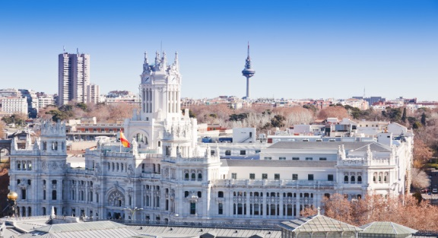
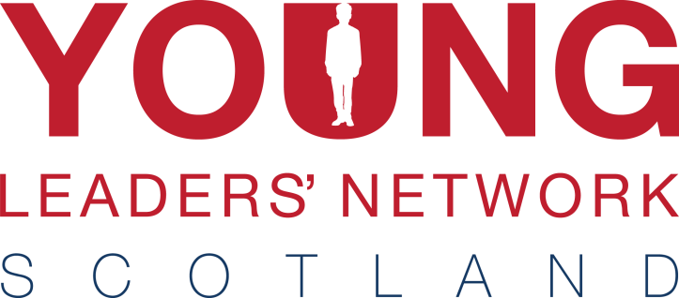
Madrid 2016

European Trip

The Summer of 2016 will see YLN travel to the incredible Spanish capital Madrid. Following on from successful trips to the likes of Rome and Lisbon, BB seniors and young leaders from across Scotland will have a chance to enjoy another international experience.

Home to more than five million people, Madrid is much more than just the capital of Spain. It has an incredible history, dating back to the 9th century, and has seen great triumph and tragedy – much of which you can still see in the city’s appearance today.

As well as being a city brimming with history, there is no shortage of things to do – from exploring the medieval quarter to exploring palaces, parks and museums – and not to mention sampling the amazing local cuisine. Above all, you’ll get to take in an amazing city has to offer in the company of other BB young people from across Scotland!

When? 27th – 29th June 2016

Who can come? BB Seniors and Young Leaders up to age of 25

What do I need? A valid passport and passion for seeing new places!

Programme A more detailed itinerary will be publicised closer to the time. However, it’s safe to say, we will pack in as much as possible. Sightseeing, sampling the local cuisine, excursions and even daft team challenges are all in the mix! There will also be free time for you to do your own exploring!

Cost We have been able to reduce the cost and plan to offer the three day, two night trip for £220. This will cover return flights to Madrid from Edinburgh, public transport, three-star hotel accommodation, dinner and insurances.

Interested? Please get in touch using the details below to register. (Places are limited so please get in touch as soon as possible)

A £50 non-refundable deposit should be returned, at the latest, by Tuesday 1st March.

If you would like some further information or have any questions regarding the trip, please get in touch with Niall Rolland by email niall.rolland@boys-brigade.org.uk or by phone 07538 079381.

For Office Use
Date recd.
Ref. No.
Bal. paid
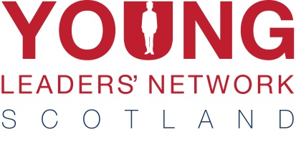
Madrid 2016

Participant’s Details:

Christian Name: ___________________ Surname: _________________ Date of Birth: _______________

Company:_________________________________________________________

Address: _______________________________________________________________________________
_______________________________________________________________________________________
_____________________________________________________________ Postcode: ________________
Tel No: Daytime: _______________ Evening: __________________ Mobile: ______________________

Email address: _______________________________________________________________________________

PLEASE COMPLETE ACCURATELY AND CAREFULLY AS DETAILS USED FOR FLIGHT BOOKINGS
Payment Details: Please √
I enclose a cheque for £50 being a non-returnable deposit for the Rome trip.
The balance to be paid, no later than 27th May 2016. Payments can be made in instalments. Total cost of trip is £220.
Please charge £________ to my Visa/Mastercard – details below
Visa/ Mastercard: _____/_____/_____/_____ Expiry Date: _____/_____ Security Code ______ (3 digit
number from signature strip on reverse of card)

Name and Address (if different from above): ____________________________________________

_______________________________________________________ Postcode: __________________

Signature:____________________________________________ Date:______________________

Please return completed form, together with the required payment to:
The Boys’ Brigade
Carronvale House
Carronvale Road
Larbert
FK5 3LH
Please make cheques payable ‘The Boys’ Brigade’

Alternatively, you can make a payment over the phone – 01324 562008 (option 1)

